**Supplementary Methods**

*Testing emergence and last observance date using unbalanced data*

Because the red colour morph was greatly outnumbered by the black colour morph in frequency, we were concerned that simple tests of differences in dates or geographic coordinates would reflect sampling error rather than true patterns in the population. So, when determining if the black and red populations were separated temporally by their first and last emergence date, we used bootstrapping to account for possible sampling error. We grouped the black colour morph larvae and downsampled them to the same size as the red morph larvae without replacement. From the black larvae resamples we calculated the 5th and 95th quantiles for each, took the mean date of observations in the 5th or 95th quantile, and modelled the distribution of sample means (n=1000). To determine if the black emergence date was sooner/later than the red emergence date from the sampling distribution, we summed the number of sample quantile means of the black morph that were sooner (for 5th percentile) or later (for 95th percentile) than the mean of the emergence dates quantiles for red morph larvae. A one-sample t-test was used to compare the black quantile sampling distribution to the mean of the red quantiles.

*Fall webworm rearing*

We collected nests of *H. cunea* larvae from several different locations and host plants in Oklahoma City, Oklahoma, and Norman, Oklahoma during August and September of 2016. We punctured holes in the lids of clean 16 oz. deli containers and placed six to eight individuals from the same nest in each. We replaced the foliage from the individuals’ respective host plants weekly while monitoring individuals for pupation. We kept the containers in incubators (Panasonic MIR-154-PA, Horsham, PA.) mimicking the average temperature for that time period, as well as light exposure mimicking typical sunrise and sunset time, from September to January (Figure S6). We set temperature and light exposure using previous years’ data for the region of Norman Oklahoma using [Weather Underground](https://www.wunderground.com/history/airport/KOUN/2016/9/20/DailyHistory.html?req_city=&req_state=&req_statename=&reqdb.zip=&reqdb.magic=&reqdb.wmo=) to control for extreme events that would otherwise affect results and analysis ([39]). Once individuals pupated, we weighed them and recorded dates. We then transferred individuals to 12 well plates (6.9 mL per well) and covered them with damp, white paper towels under the lids. We changed paper towels weekly to reduce desiccation and checked pupae for moisture and fungal growth. We held pupae at a constant 4 ºC starting the beginning of February. During this period, we sexed individual pupae by identifying the relative location of the genital slit under a dissecting microscope, as described by Loewy [20].

**Supplementary Results**

Full-sized figures and formatted tables available at <https://osf.io/x64gp/?view_only=cb630bc7e24d487a9fdaa1a5682e82cb>

Supplementary Table 1. Coefficients of linear discriminants from LDA analysis of variables separating colouration of red and black morphs in iNaturalist photographs. Among the coefficients of linear discriminants, the mean green value, mean red value, and red standard deviation have the highest absolute values (-2.73, 1.87, and -1.18 respectively).

|  |  |
| --- | --- |
| *Variable* | *Value* |
| *RedMean* | *1.870682* |
| *RedSkew* | *0.801723* |
| *BlueMax* | *0.74419* |
| *RedMin* | *0.726529* |
| *BlueSD* | *0.610578* |
| *GreenKurt* | *0.412499* |
| *GreenSD* | *0.327249* |
| *RedMax* | *0.269384* |
| *BlueMean* | *0.168639* |
| *BlueKurt* | *-0.05317* |
| *GreenSkew* | *-0.0597* |
| *BlueMin* | *-0.14035* |
| *GreenMin* | *-0.30519* |
| *RedKurt* | *-0.30801* |
| *BlueSkew* | *-0.5728* |
| *GreenMax* | *-0.68131* |
| *RedSD* | *-1.17772* |
| *GreenMean* | *-2.72593* |

Supplementary Table 2. Top five component loadings from a sparse partial least squares analysis of metabolites (Fig. 3C) in the red and black colour morphs of the fall webworm *H. cunea*.

|  |  |  |  |  |
| --- | --- | --- | --- | --- |
| **Component** | **Loading** | **Mass (m/z)** | **Retention Time (minutes)** | **Putative metabolite** |
| 1 | -0.51 | 155.04 | 3.00 | N-Methylethanolamine phosphate |
| 1 | -0.51 | 257.14 | 2.59 | Arg-Lys-Asp-Pro |
| 1 | -0.40 | 166.06 | 11.04 | 3-(3-Hydroxy-phenyl)-propanoic acid |
| 1 | -0.37 | 384.14 | 10.74 | Lys-Thr-His |
| 1 | -0.31 | 168.03 | 1.33 | Urate |
|  |  |  |  |  |
| 2 | 0.70 | 525.33 | 13.82 | Not assigned |
| 2 | 0.39 | 858.53 | 17.20 | PI(36:4) |
| 2 | 0.33 | 553.25 | 6.28 | Gln-Phe-Pro-Tyr |
| 2 | 0.31 | 513.18 | 6.09 | Asp-Asp-Gln-His |
| 2 | 0.29 | 53.32 | 12.52 | Arg-Lys-Met-Val |

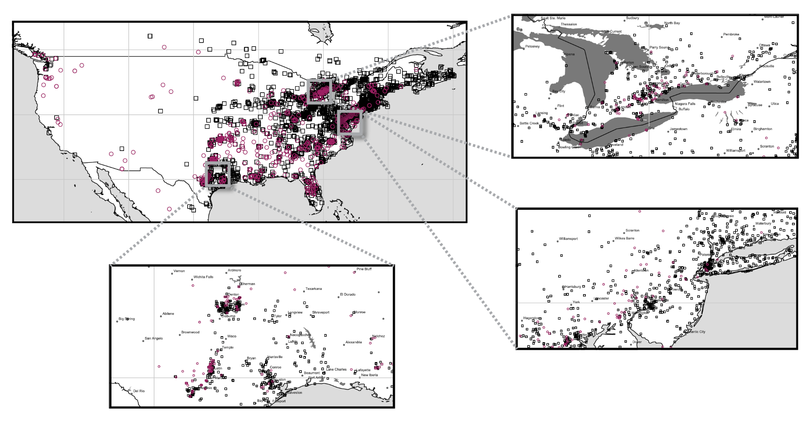

**Figure S1.** Regional distribution of iNaturalist fall webworm observations from 2018-2020 with colour morph indicated. Red and black morph fall webworms occur sympatrically at a regional and local level, implicating a sympatric form of speciation. Regions shown are southern Ontario, northeastern USA, and southern Texas.

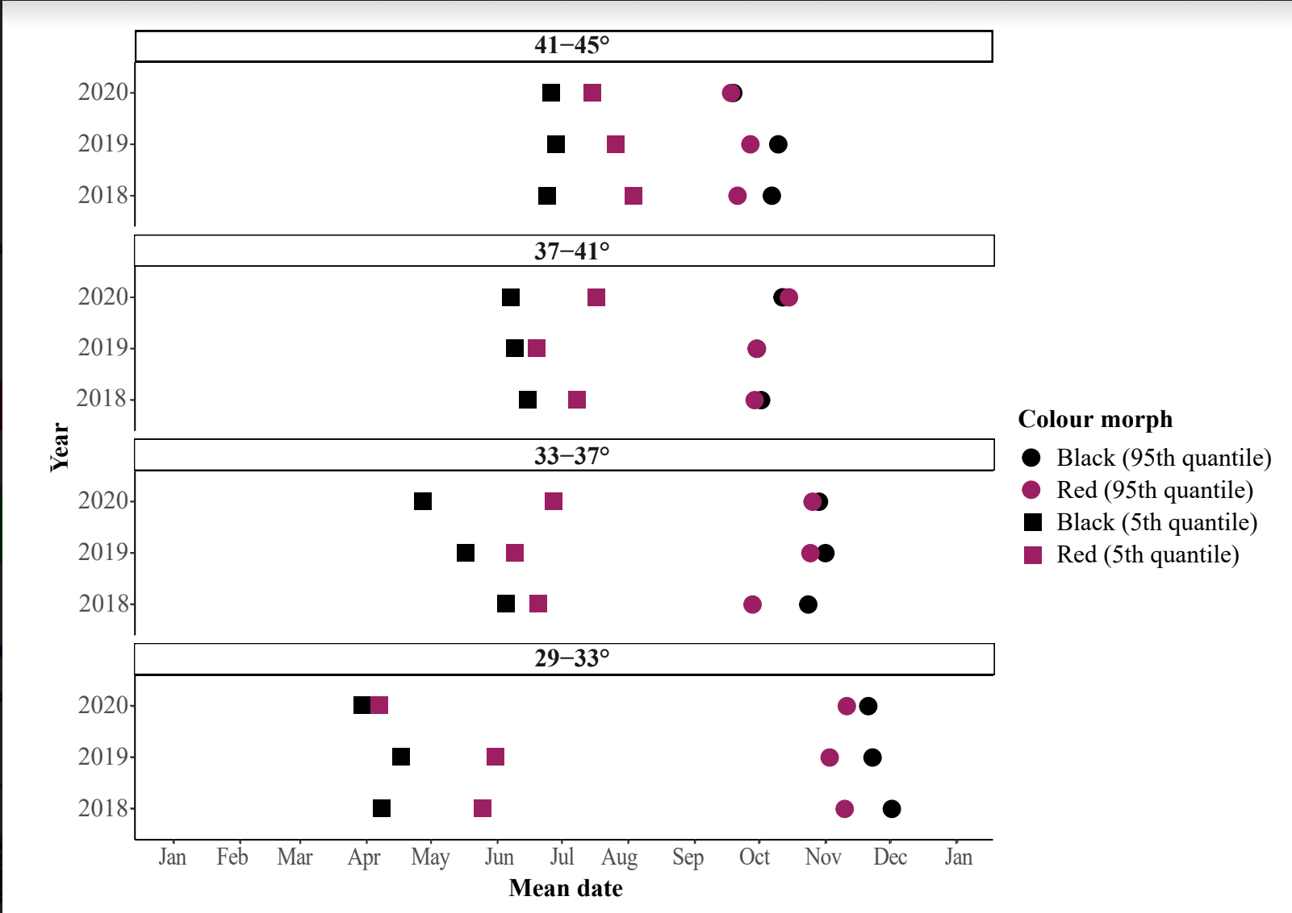

**Figure S2.** Timing of first and last emergence of black and red morph fall webworm larvae across their latitudinal range from 2018-2020. Across all years and latitudes, the black appears on average 30 days earlier than the red (Wilcox two-sided, *P*<0.001) and remains 10 days later (Wilcox two-sided, *P*<0.01). Points represent either the mean of all observations less than the 5th quantile (“5th Quantile”) or the mean of all observations greater than the 95th quantile (“95th Quantile”). Black observations were down-sampled to account for differences in number of observations between the red and black.

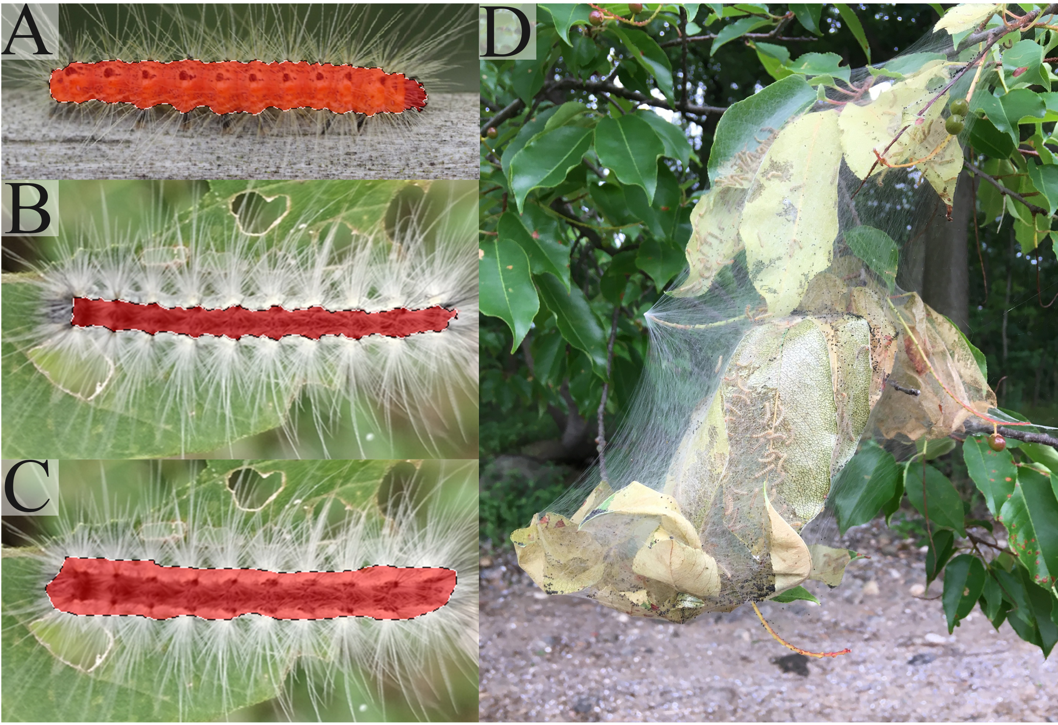

**Figure S3.** Fall webworm image isolation and selection in Adobe Photoshop for colour phenotype analysis. A) Complete isolation of fall webworm larva by Photoshop using object detection tool, no manual adjustment needed. B) Incomplete selection of fall webworm larva by object detection tool. Corrected manually by researcher using freehand lasso tool. C) Complete selection of fall webworm larva in Photoshop after manual correction using freehand lasso tool. D) Example of photo removed from colour phenotype analysis. Photo was low resolution, had poor exposure, was taken from a far distance, and had an object obstructing the webworms. Photos shown here obtained from iNaturalist.org under public domain licensing (CC0).



**Figure S4.** Animated RGB histogram of red and black fall webworm larvae across their latitudinal range.

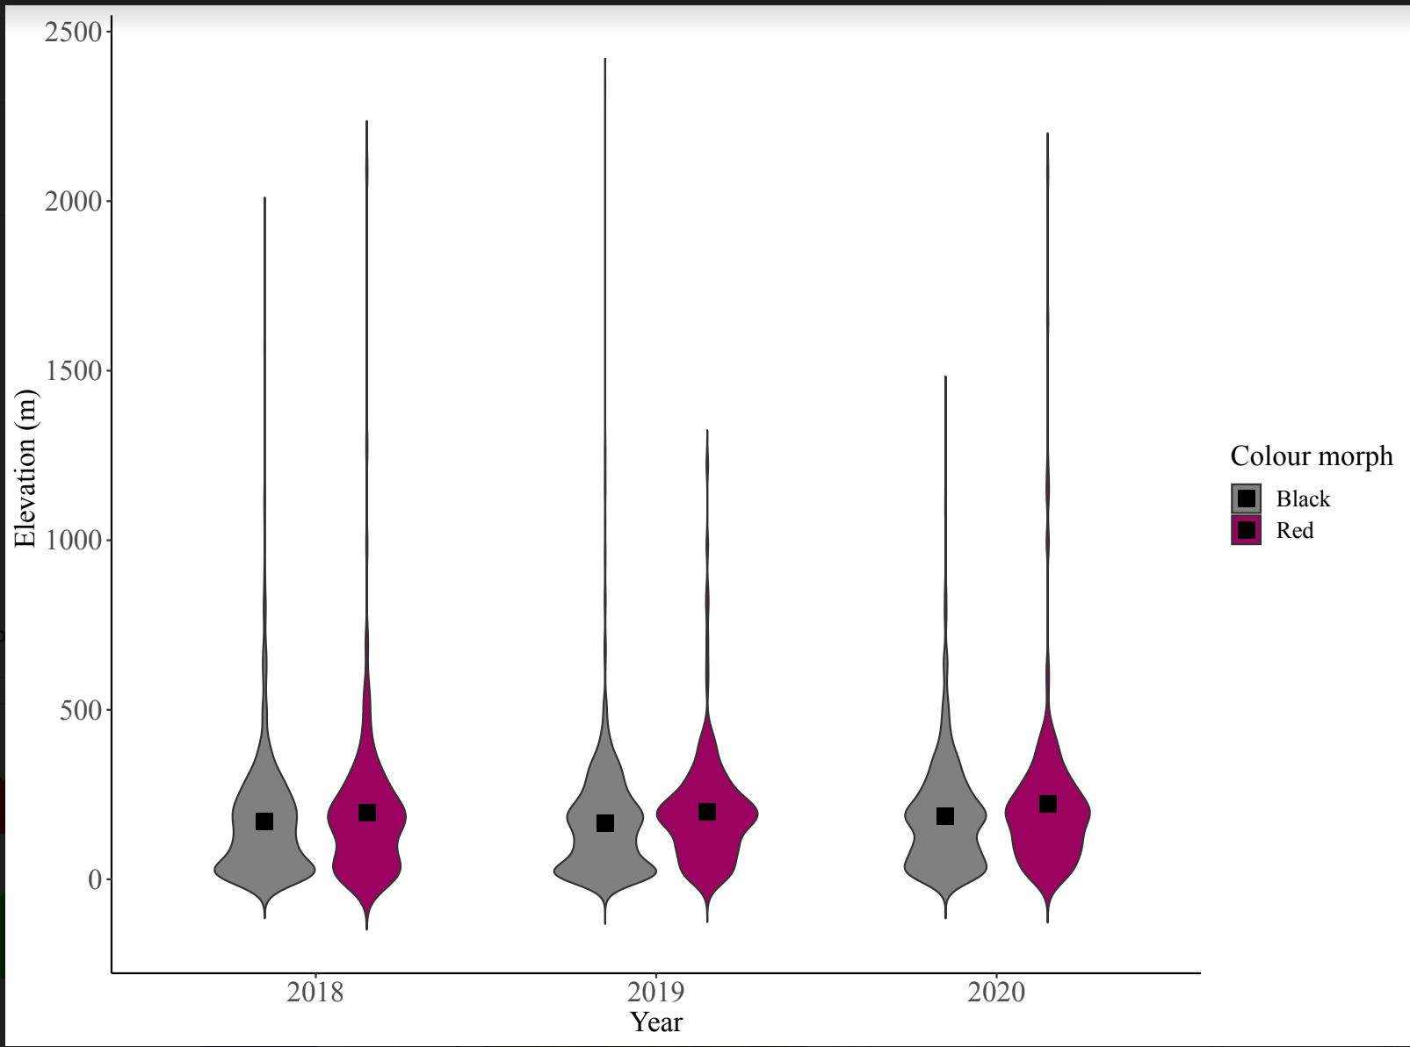

**Figure S5.** Elevational distribution of red and black fall webworm larvae from 2018-2020. The red morph was found at an average of 32m higher elevation than the black morph (F1,4578 =20.345, *P*<0.0001, Figure S5) with no interaction with year (F2,4578=0.128, *P*=0.880), however a Tukey-Kramer post-hoc analysis found that the elevation difference was not significant in each year.

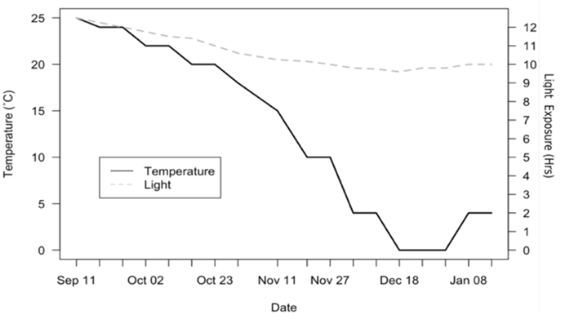

**Figure S6**. Changes in temperature and light exposure in incubators over time, set to the average temperature and light exposure hours from September 2016 to January 2016 using previous years’ average data for the region of Norman Oklahoma (Weather Underground) to control for extreme events that would otherwise differentially affect results and analysis.